**Assignment -2**

Python Programming

|  |  |
| --- | --- |
| Assignment Date | 22 September 2022 |
| Student Name | S. Siva |
| Student Roll Number | 710619205006 |
| Maximum Marks | 2 Marks |

**Question:**

Build a python code, assume u get temperature and humidity values (generated with random function to a variable) and write a condition to continuously detect alarm in case of high temperature.

**Solution:**

import random

import time

temp=random.randint(0,100)

print("The temperature is:",temp)

humid=random.randint(0,50)

print("The humidity is:",humid,"%")

if temp>50:

print("high Temperature")

for i in range(5):

time.sleep(1)

print("\a")

else:

print("Normal")

if humid>25:

print("High Humid")

for i in range(5):

time.sleep(1)

print("\a")

else:

print("Normal")

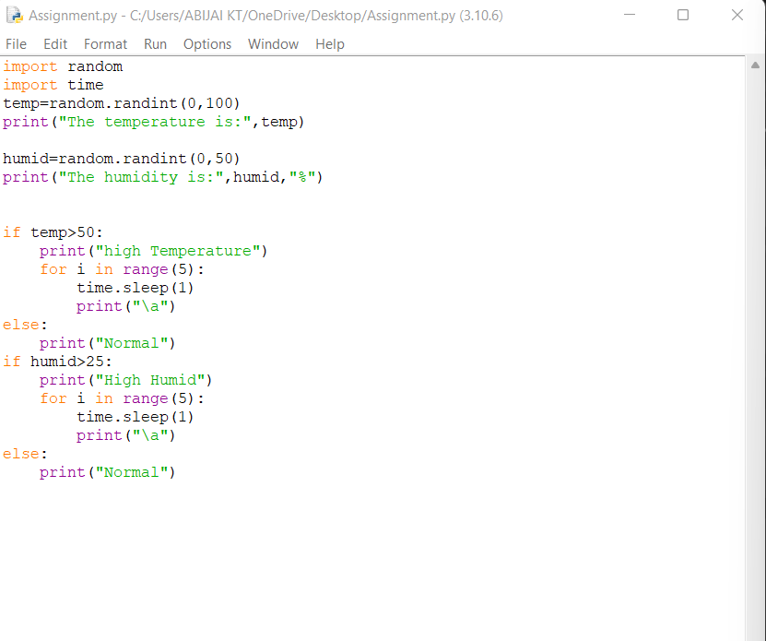

Output:

